



Below are some fundraisers that are student friendly, teacher friendly, and school friendly for any age! With every fundraiser there are easy steps to what supplies you will need and how to set up the fundraiser!

**Spot that Baby!**

**What:** Teachers and staff at your school bring in a child picture of themselves as a baby! The students get to pay to guess a teacher!

**Price:** The price of a guess is really up to you! We suggest you keep it under $1 for 1 guess and can give multiple guesses for $1 or$2. (Example: 1 guess- 25¢ or 5 guesses for $1)

**Set-UP:** Before your fundraiser set up posters around the school telling students the 5 W’s to your fundraiser (Who are the participating teachers, what is your fundraiser, Where will it take place, Why are you doing it, When will your fundraiser happen.) Make sure you have a teacher’s permission before you put up your posters.

On fundraiser day(s) set up your table, cash box, and pictures. Make sure to set up in a location easy for students to find!

**Pictures:** On the baby picture you put a letter. On the teachers name or current letter you put a number. For (example: A1 is Mr. Stephen’s baby picture on A and 1 will be Mr. Stephen’s name.)

**Supplies:** Table, Tape, Pictures, Cash box, and posters, and answer key.

**Reminders:** You will need student volunteers to run your station. We suggest for younger grades to have an adult volunteer too, to help with money.

If the guesser gets it right you can supply them with a small price such as a candy, but that is really you and your teacher’s decision!

[](http://www.google.ca/url?sa=i&rct=j&q=&esrc=s&frm=1&source=images&cd=&cad=rja&docid=uj-K4cMNiVJ7gM&tbnid=n7r_6HhPtvqv5M:&ved=0CAUQjRw&url=http%3A%2F%2Fwww.strawberryfields.org%2Fraffle-winners-2013%2F&ei=fSxsUpjiIOGyiQK-7oHIDg&bvm=bv.55123115,d.cGE&psig=AFQjCNH54Md6eOfgcJXounBfy0EegPelfg&ust=1382907193826205)**Raffle!**

**What:** Students and teachers can buy a ticket for the chance to win cool prizes of your schools decision.

**Price:** The price of a ticket is really up to you! We suggest you keep it under $1 for 1 ticket and can give multiple tickets for $1 or$2. (Example: 1 guess- 25¢ or 10 guesses for $2)

**Set-UP:** Before your fundraiser set up posters around the school telling students the 5 W’s to your fundraiser (Who are the participating teachers, what is your fundraiser, Where will it take place, Why are you doing it, When will your fundraiser happen.) Make sure you have a teacher’s permission before you put up your posters.

On fundraiser day(s) set up your table, cash box, and tickets. Make sure to set up in a location easy for students to find!

**Tickets:** On the ticket make sure the purchaser puts their first and last name and their grade.

**Supplies:** Table, Tape, tickets, pens, Cash box, and posters.

**Reminders:** You will need student volunteers to run your station. We suggest for younger grades to have an adult volunteer too, to help with money.

**Prizes:** This section is really up for you to decide. Some suggestions would be gift cards to stores and companies in your area, candy, school clothing, etc. You can also raffle off a “get out of class” card but need principal approval.

[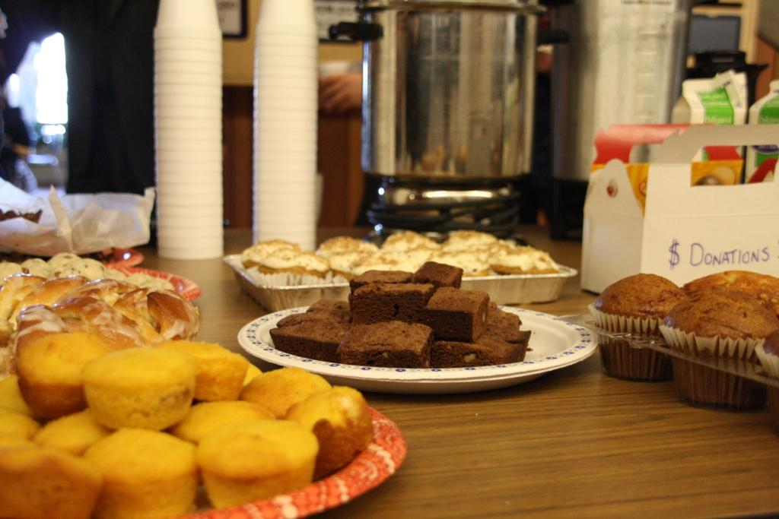](http://www.google.ca/url?sa=i&rct=j&q=&esrc=s&frm=1&source=images&cd=&cad=rja&docid=rVzNrkMzIDAC8M&tbnid=jRTmlesVy1pKzM:&ved=0CAUQjRw&url=http%3A%2F%2Fwww.chemistry.sfu.ca%2Fabout%2FDepartmentalEvents%2Fbakesale&ei=zVlsUu6hEsKpiQKbqYCgAQ&bvm=bv.55123115,d.cGE&psig=AFQjCNEV9mvlQEM10ZCSWxZ6sW0OmBpQsA&ust=1382918963337685)

**Bake Sale!**

**What:** Students and teachers can buy baked items made by other students or teachers.

**Price:** The price is up to you to decide. We suggest that you price items based on popularity and size. (For example a chocolate chip cookie $1 or a decorate cupcake for $2.00

**Set-UP:** Before your fundraiser set up posters around the school telling students the 5 W’s to your fundraiser (Who are the participating teachers, what is your fundraiser, Where will it take place, Why are you doing it, When will your fundraiser happen.) Make sure you have a teacher’s permission before you put up your posters. Make sure you also have people sign up to bring in baked goods too. You can talk to you student council, foods class, leadership class to get more stuff.

On fundraiser day(s) set up your table, cash box, and goods. Make sure to set up in a location easy for students to find! Also make sure you stick all the goods with a price or make a list with prices.

**Supplies:** Table, Tape, baked treats stickers, pens, Cash box, and posters.

**Reminders:** You will need student volunteers to run your station. We suggest for younger grades to have an adult volunteer too, to help with money. Bake sales are awesome to have at a school game, band concert, or even during lunch hour.

[](http://www.google.ca/url?sa=i&rct=j&q=&esrc=s&frm=1&source=images&cd=&cad=rja&docid=Tg9tSWCy-9S5IM&tbnid=pWnoAud1E6m4tM:&ved=0CAUQjRw&url=http%3A%2F%2Fwww.downtownphoenix.com%2Fblog%2Ftag%2Fcaroling%2F&ei=XHFsUo3ZBq_MigL9v4HYDQ&bvm=bv.55123115,d.cGE&psig=AFQjCNFX-QOrg2GJEHhnVyANSH-_oIMvLQ&ust=1382925016359194)

**Christmas Caroling**

**What:** Students go door to door caroling for donations.

**Price:** There is no fixed price, depends on what the donor wants to give.

**Set-UP:** Before your fundraiser set up posters around the school telling students the 5 W’s to your fundraiser (Who are the participating teachers, what is your fundraiser, Where will it take place, Why are you doing it, When will your fundraiser happen.) Make sure you have a teacher’s permission before you put up your posters. Also tell these 5 W’s to your local media so people know your coming. Make sure you also have people sign up be apart since it is an after school fundraiser.

On fundraiser day(s) set up groups at a location. We suggest all volunteers meeting at the school parking lot, so everyone knows the place.

**Supplies:** Small box to collect cash, song lyrics.

**Reminders:** Make sure you get lots of different lyrics of classic Christmas songs everyone knows! Make sure that younger kids are accompanied by an adult when going door to door.

[](http://www.google.ca/url?sa=i&rct=j&q=&esrc=s&frm=1&source=images&cd=&cad=rja&docid=d9Tvs98veHw-NM&tbnid=NRebnXgpCmjdyM:&ved=0CAUQjRw&url=http%3A%2F%2Fwww.mymcmurray.com%2Ffather-beauregard-bottle-drive%2F&ei=dnJsUvTfEqiQiQLx5YH4AQ&bvm=bv.55123115,d.cGE&psig=AFQjCNGrPlGjkxALye8An7iBul_AvYeu6A&ust=1382925295034501)

**Bottle Drive**

**What:** Students go door to door collecting bottles.

**Price:** Take your bottles and cans to the nearest bottle depot for money exchange.

**Set-UP:** Before your fundraiser set up posters around the school telling students the 5 W’s to your fundraiser (Who are the participating teachers, what is your fundraiser, Where will it take place, Why are you doing it, When will your fundraiser happen.) Make sure you have a teacher’s permission before you put up your posters. Also tell these 5 W’s to your local media so people know your coming. Make sure you also have people sign up be apart since it is an after school fundraiser.

On fundraiser day(s) set up groups at a location. We suggest all volunteers meeting at the school parking lot.

**Supplies:** Small box to collect cash donations, garbage bags, vehicles, plastic gloves, and maps of who is doing what section of your community.

**Reminders:** This is a very successful fundraisers for larger groups such as sports teams or school bands. Make sure that younger kids are accompanied by an adult when going door to door.

[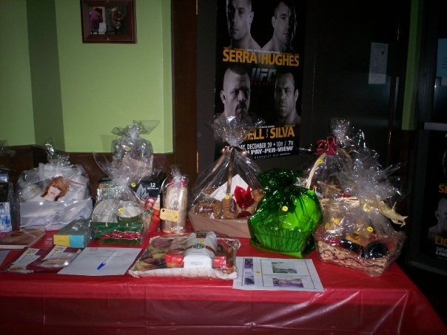](http://www.google.ca/url?sa=i&rct=j&q=&esrc=s&frm=1&source=images&cd=&cad=rja&docid=T82I_TE5I5HUmM&tbnid=AvhNUvCUe2DFXM:&ved=0CAUQjRw&url=http%3A%2F%2Fwww.kwantlen.ca%2Farts%2Fhistory%2Fkhss.html&ei=Q3RsUtu-JqjDiwKsvYCACA&bvm=bv.55123115,d.cGE&psig=AFQjCNF0K_NuqZJgoZAGIXq_ONiSsTAozg&ust=1382925752846589)

**Silent Auction**

**What:** At your next school sports game, drama play, or music concert set up a mini silent auction

**Price:** Put a minimum price on items based on their worth. (Example: tool box $10)

**Set-UP:** Before your fundraiser set up posters around the school telling students the 5 W’s to your fundraiser (Who are the participating teachers, what is your fundraiser, Where will it take place, Why are you doing it, When will your fundraiser happen.) Make sure you have a teacher’s permission before you put up your posters. Also tell these 5 W’s to your local media so people know your coming. Make sure you also have people sign up be apart since it is an after school fundraiser.

On fundraiser day(s) set up tables and place items on tables with a bidding sheet for each item. On the bidding sheet make sure to ask for their full name and contact information as well as what their bidding price may be.

**Supplies:** Cash box to collect donations, table, bidding form, and auction items. Make sure to talk to your schools option classes to see if artwork, cakes or pastries, or industrial arts items could be raffled.

**Reminders:** This is a fundraiser that parents will be more successful as donors so make sure what you are auctioning off is parent friendly. A silent auction for kids is more successful as a raffle. To get items donated send businesses a letter explaining your fundraiser and the item you are requesting. The highest amount at the end of the night is who wins that item.



These are just some examples. We want to see your fundraisers and ideas too! Email [stephensbackpacks.photoshare@gmail.com](mailto:stephensbackpacks.photoshare@gmail.com) with your pictures of fundraisers! Make sure to include your school name or group, who’s in the picture, and what you’re doing! All pictures will be shared VIA facebook, twitter, and our website. Still got questions? Email us at director@stephensbackpacks.com .

[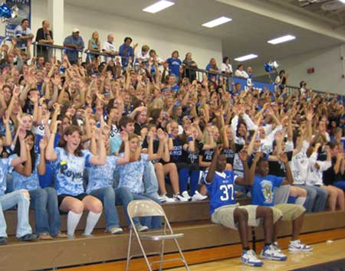](http://www.google.ca/url?sa=i&rct=j&q=&esrc=s&frm=1&source=images&cd=&cad=rja&docid=u_kXvI9eYqBAuM&tbnid=inBBU8hjh2GFIM:&ved=0CAUQjRw&url=http%3A%2F%2Fwww.threesixtyjournalism.org%2Farticle%2F2009-03%2Fwoodbury-high-school&ei=unZsUqq8D6KdiALYpYGQDQ&bvm=bv.55123115,d.cGE&psig=AFQjCNH-9EArnbjc00LVPamDPCofZr7LYw&ust=1382926392459358)

**Sports Game**

**What:** A sports game of your school team against another!

**Price:** Between $2 and $5 for admission into the game.

**Set-UP:** Before your fundraiser set up posters around the school telling students the 5 W’s to your fundraiser (Who are the participating teachers, what is your fundraiser, Where will it take place, Why are you doing it, When will your fundraiser happen.) Make sure you have a teacher’s permission before you put up your posters. Also tell these 5 W’s to your local media so people know your coming. Make sure you also have people sign up be apart since it is an after school fundraiser.

On fundraiser day(s) set up table at entrance into gymnasium to collect tickets or cash for entrance.

**Supplies:** Cash box to collect donations, table, and tickets.

**Reminders:** This is a fundraiser that can be successful during school or on an evening. If it is during school make school you have permission from both schools for their students and athletes to miss class. You can pre-sell your tickets or sell them at the door. Pre-selling will make it faster for people to enter the gymnasium. You could always pre-sell and still sell at the door, because someone always forgets to buy their tickets ahead of time.